- PYNQ SoC framework is used to command and control the SoC and RTL LENET Neural Network within the synthesized bitstream.
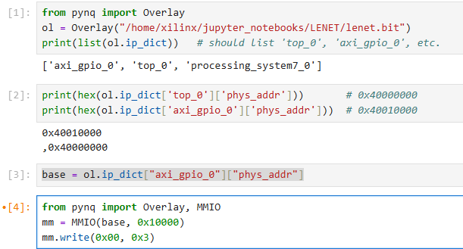

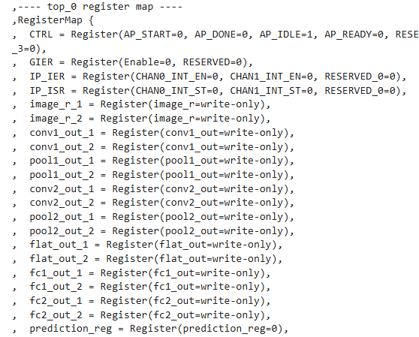
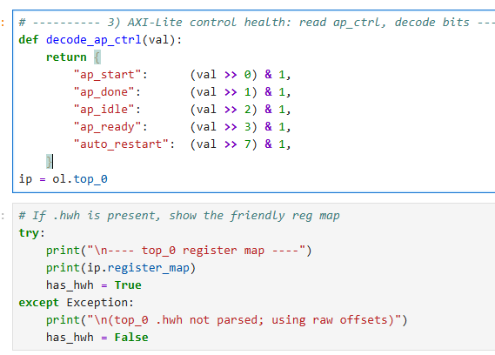
- PYNQ Framework allows for read and write of hardware specific registers and DDR memory to load test frames for neural network.

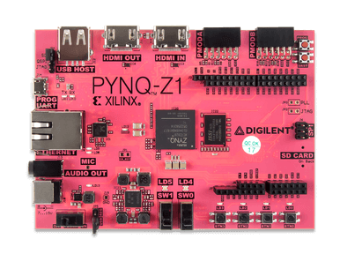
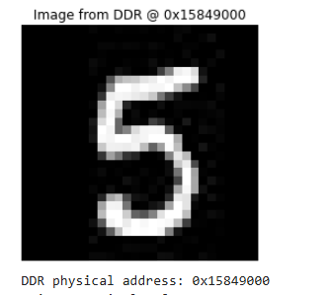
- The desired test image is loaded into the input registers and read back from DDR to ensure the correct image is loaded into the hardware.
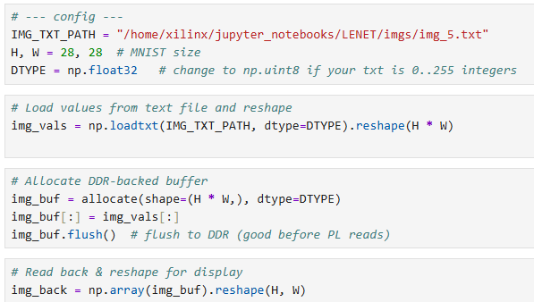
- Each layer is prepared for arithmetic checkout of the neural network convolution and the final layer calculates the prediction of the digit.
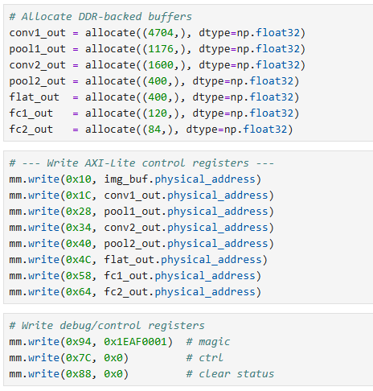
- Finally, the inference ran within the PYNQ framework and polls the prediction register after the neural network finishes processing, yielding the correct prediction, within this test, the input digit is 5, and the prediction is 5.
